CN Lab 04 Home Task:

Name: Owais Ali Khan

Section: 6-F

Roll no: 21K-3298

Task 02:

HTTP Packet:
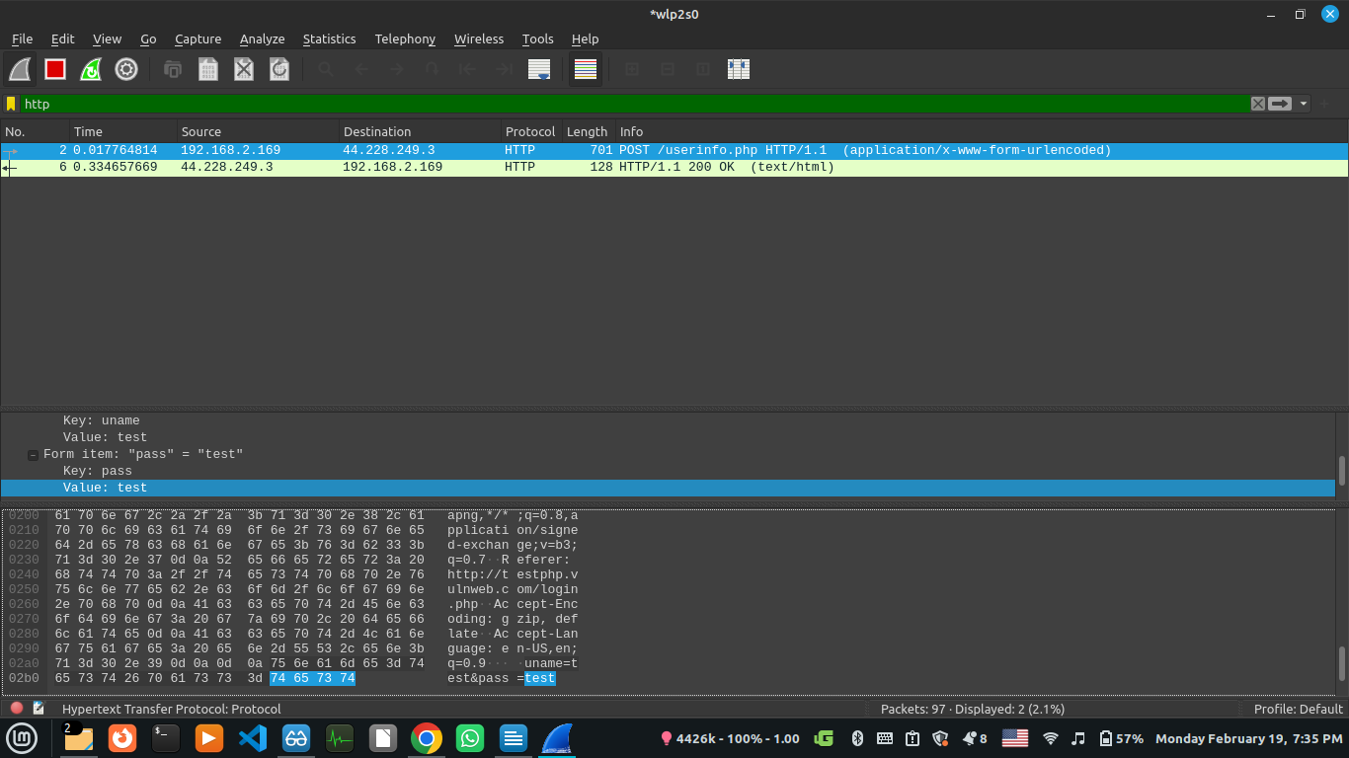
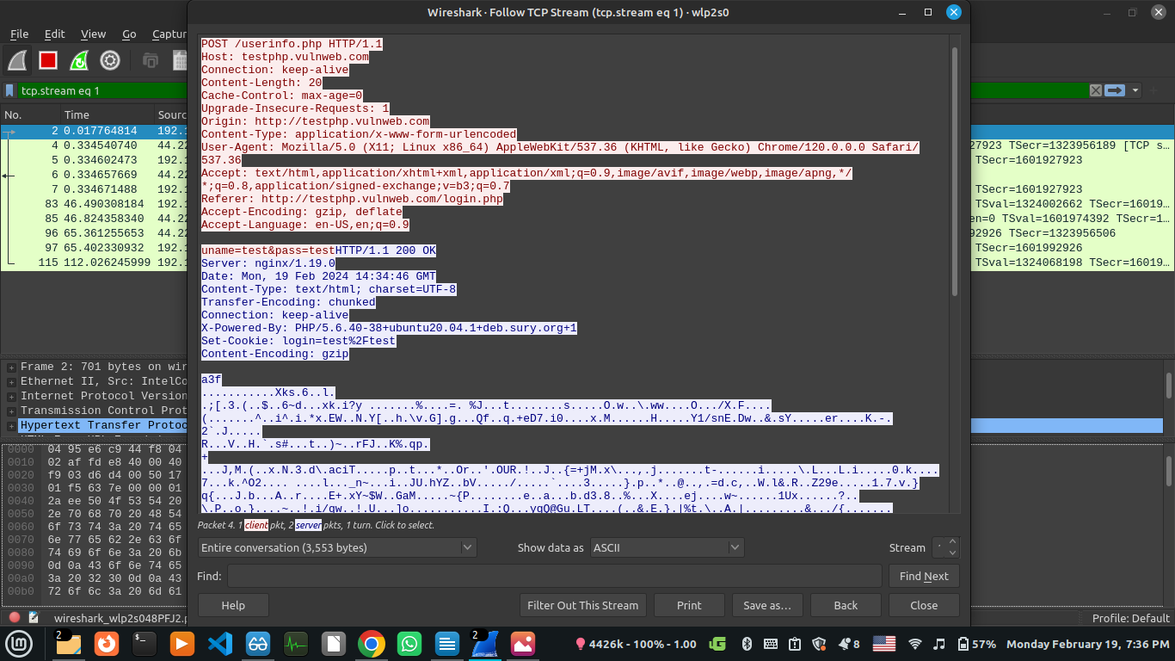

HTTPS Packet:
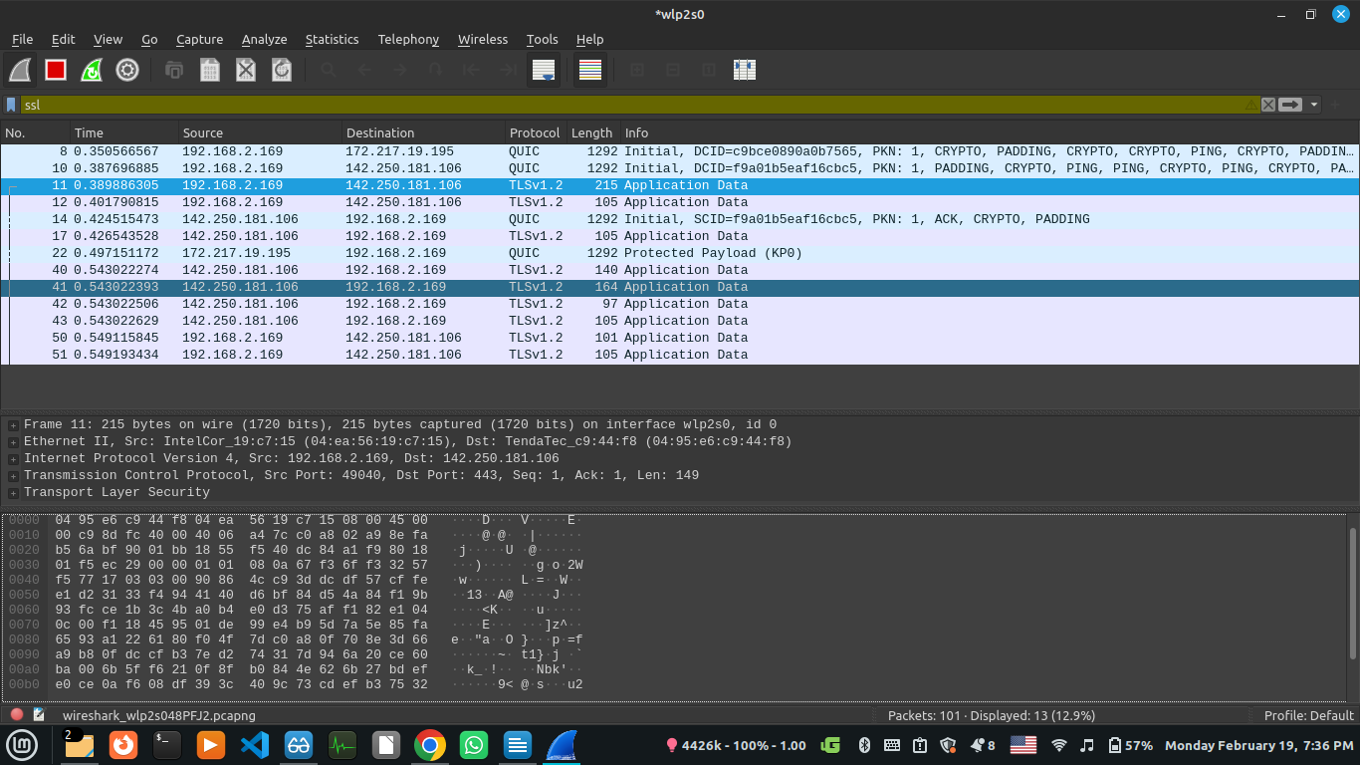
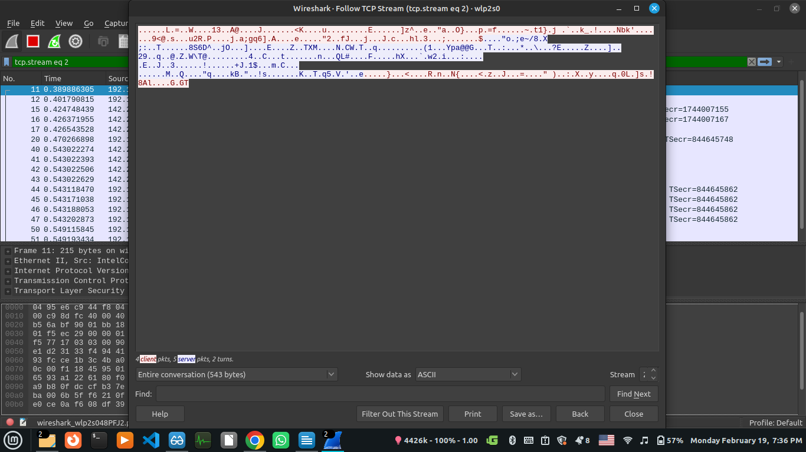

We can see from the above screenshots that packets sent over HTTP are in plaintext meaning that they can be read by any malicious actor between their source and destination. However, the packets sent over HTTPS (using SSL/TLS encryption) are in ciphertext meaning that they are of no use until they are decrypted at the destination.
Thus HTTPS provides more security than simple HTTP.

